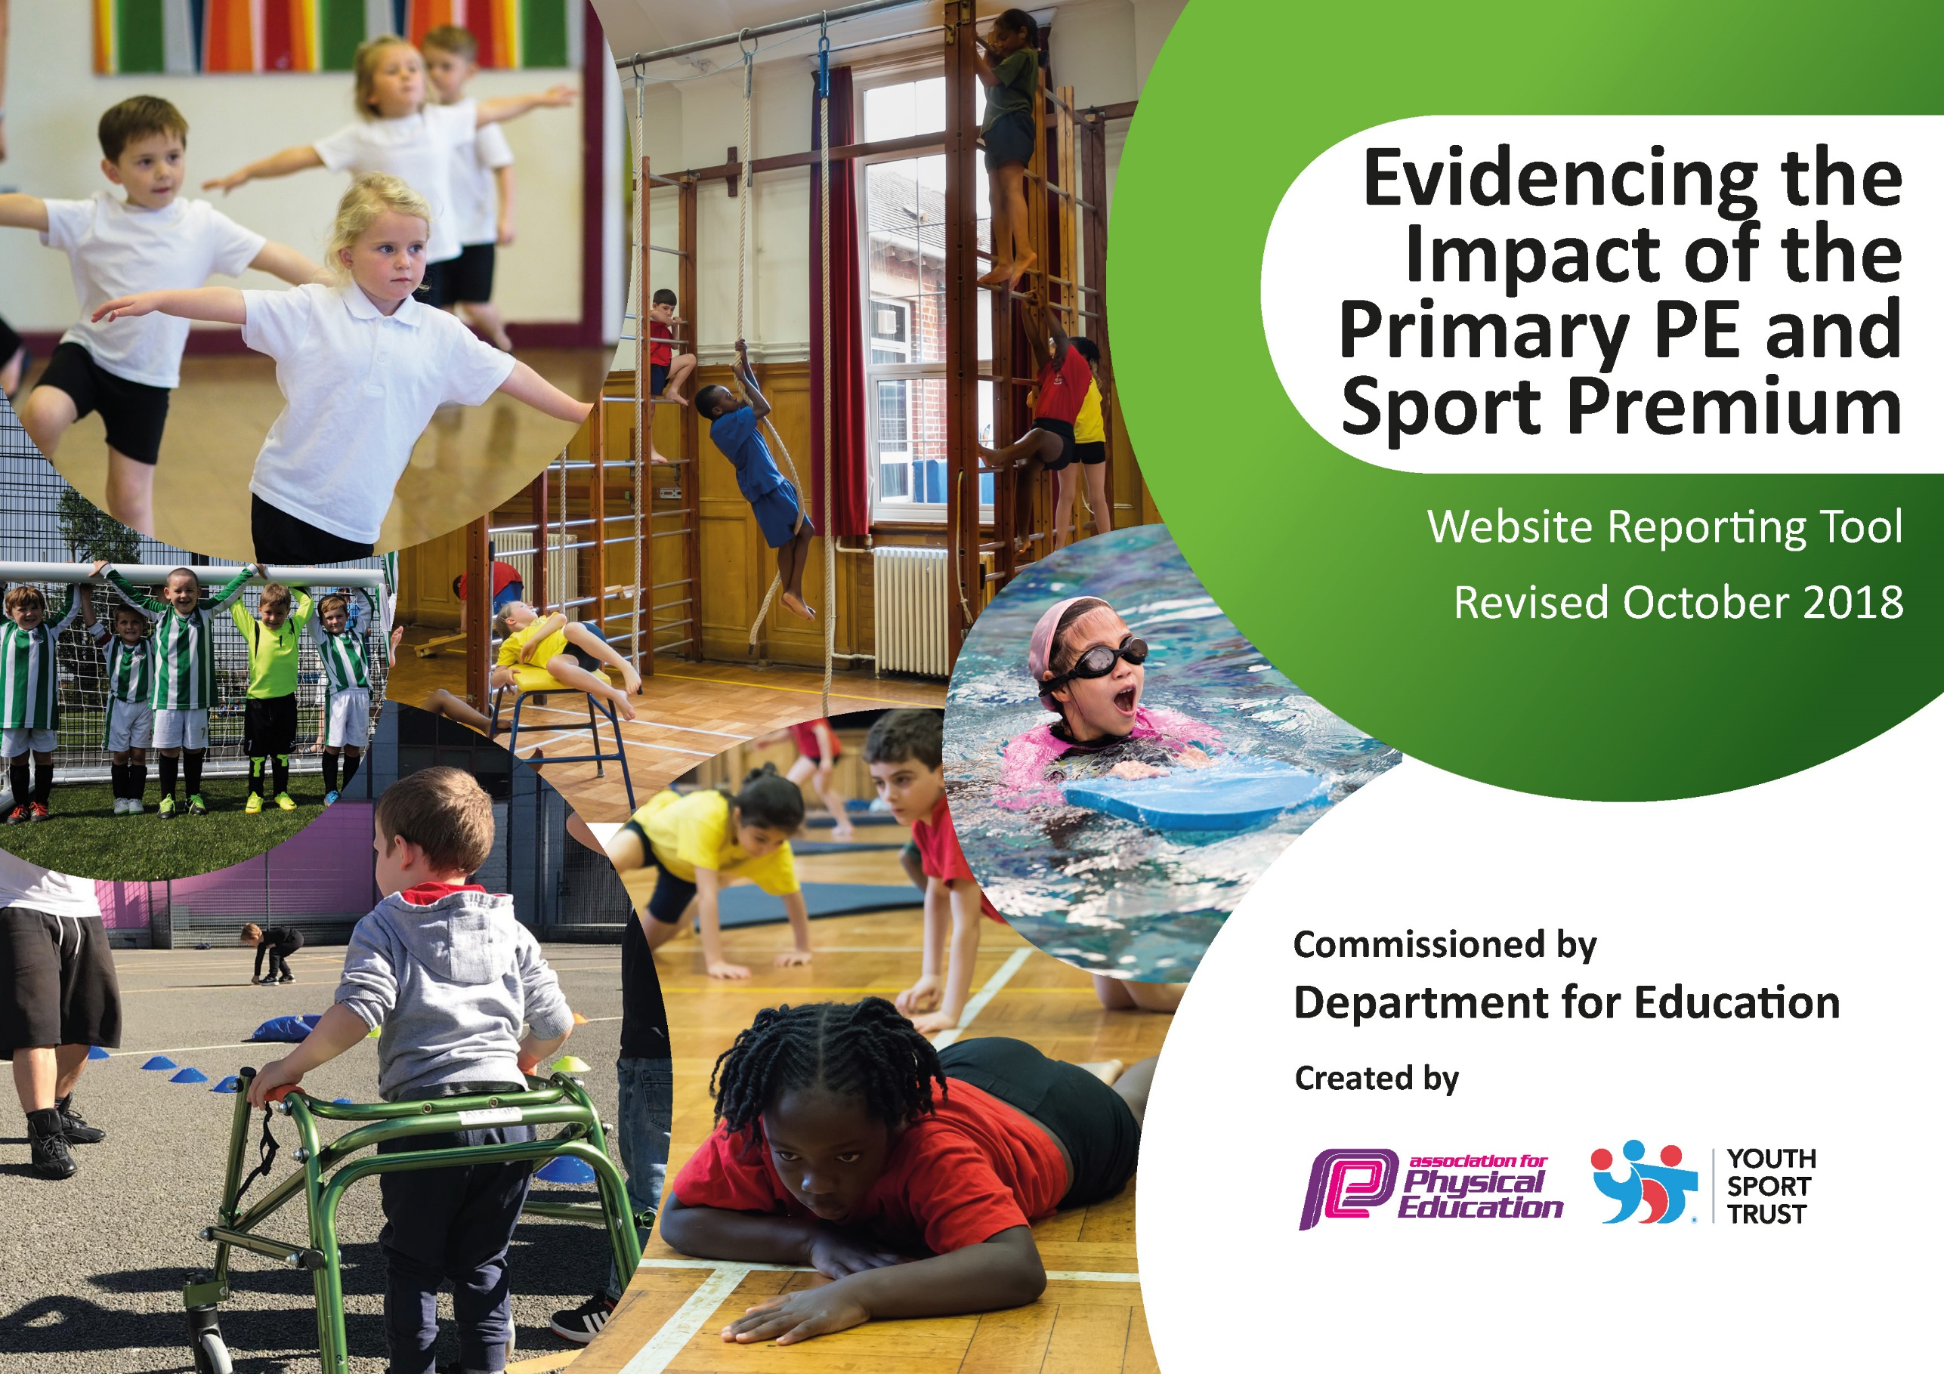

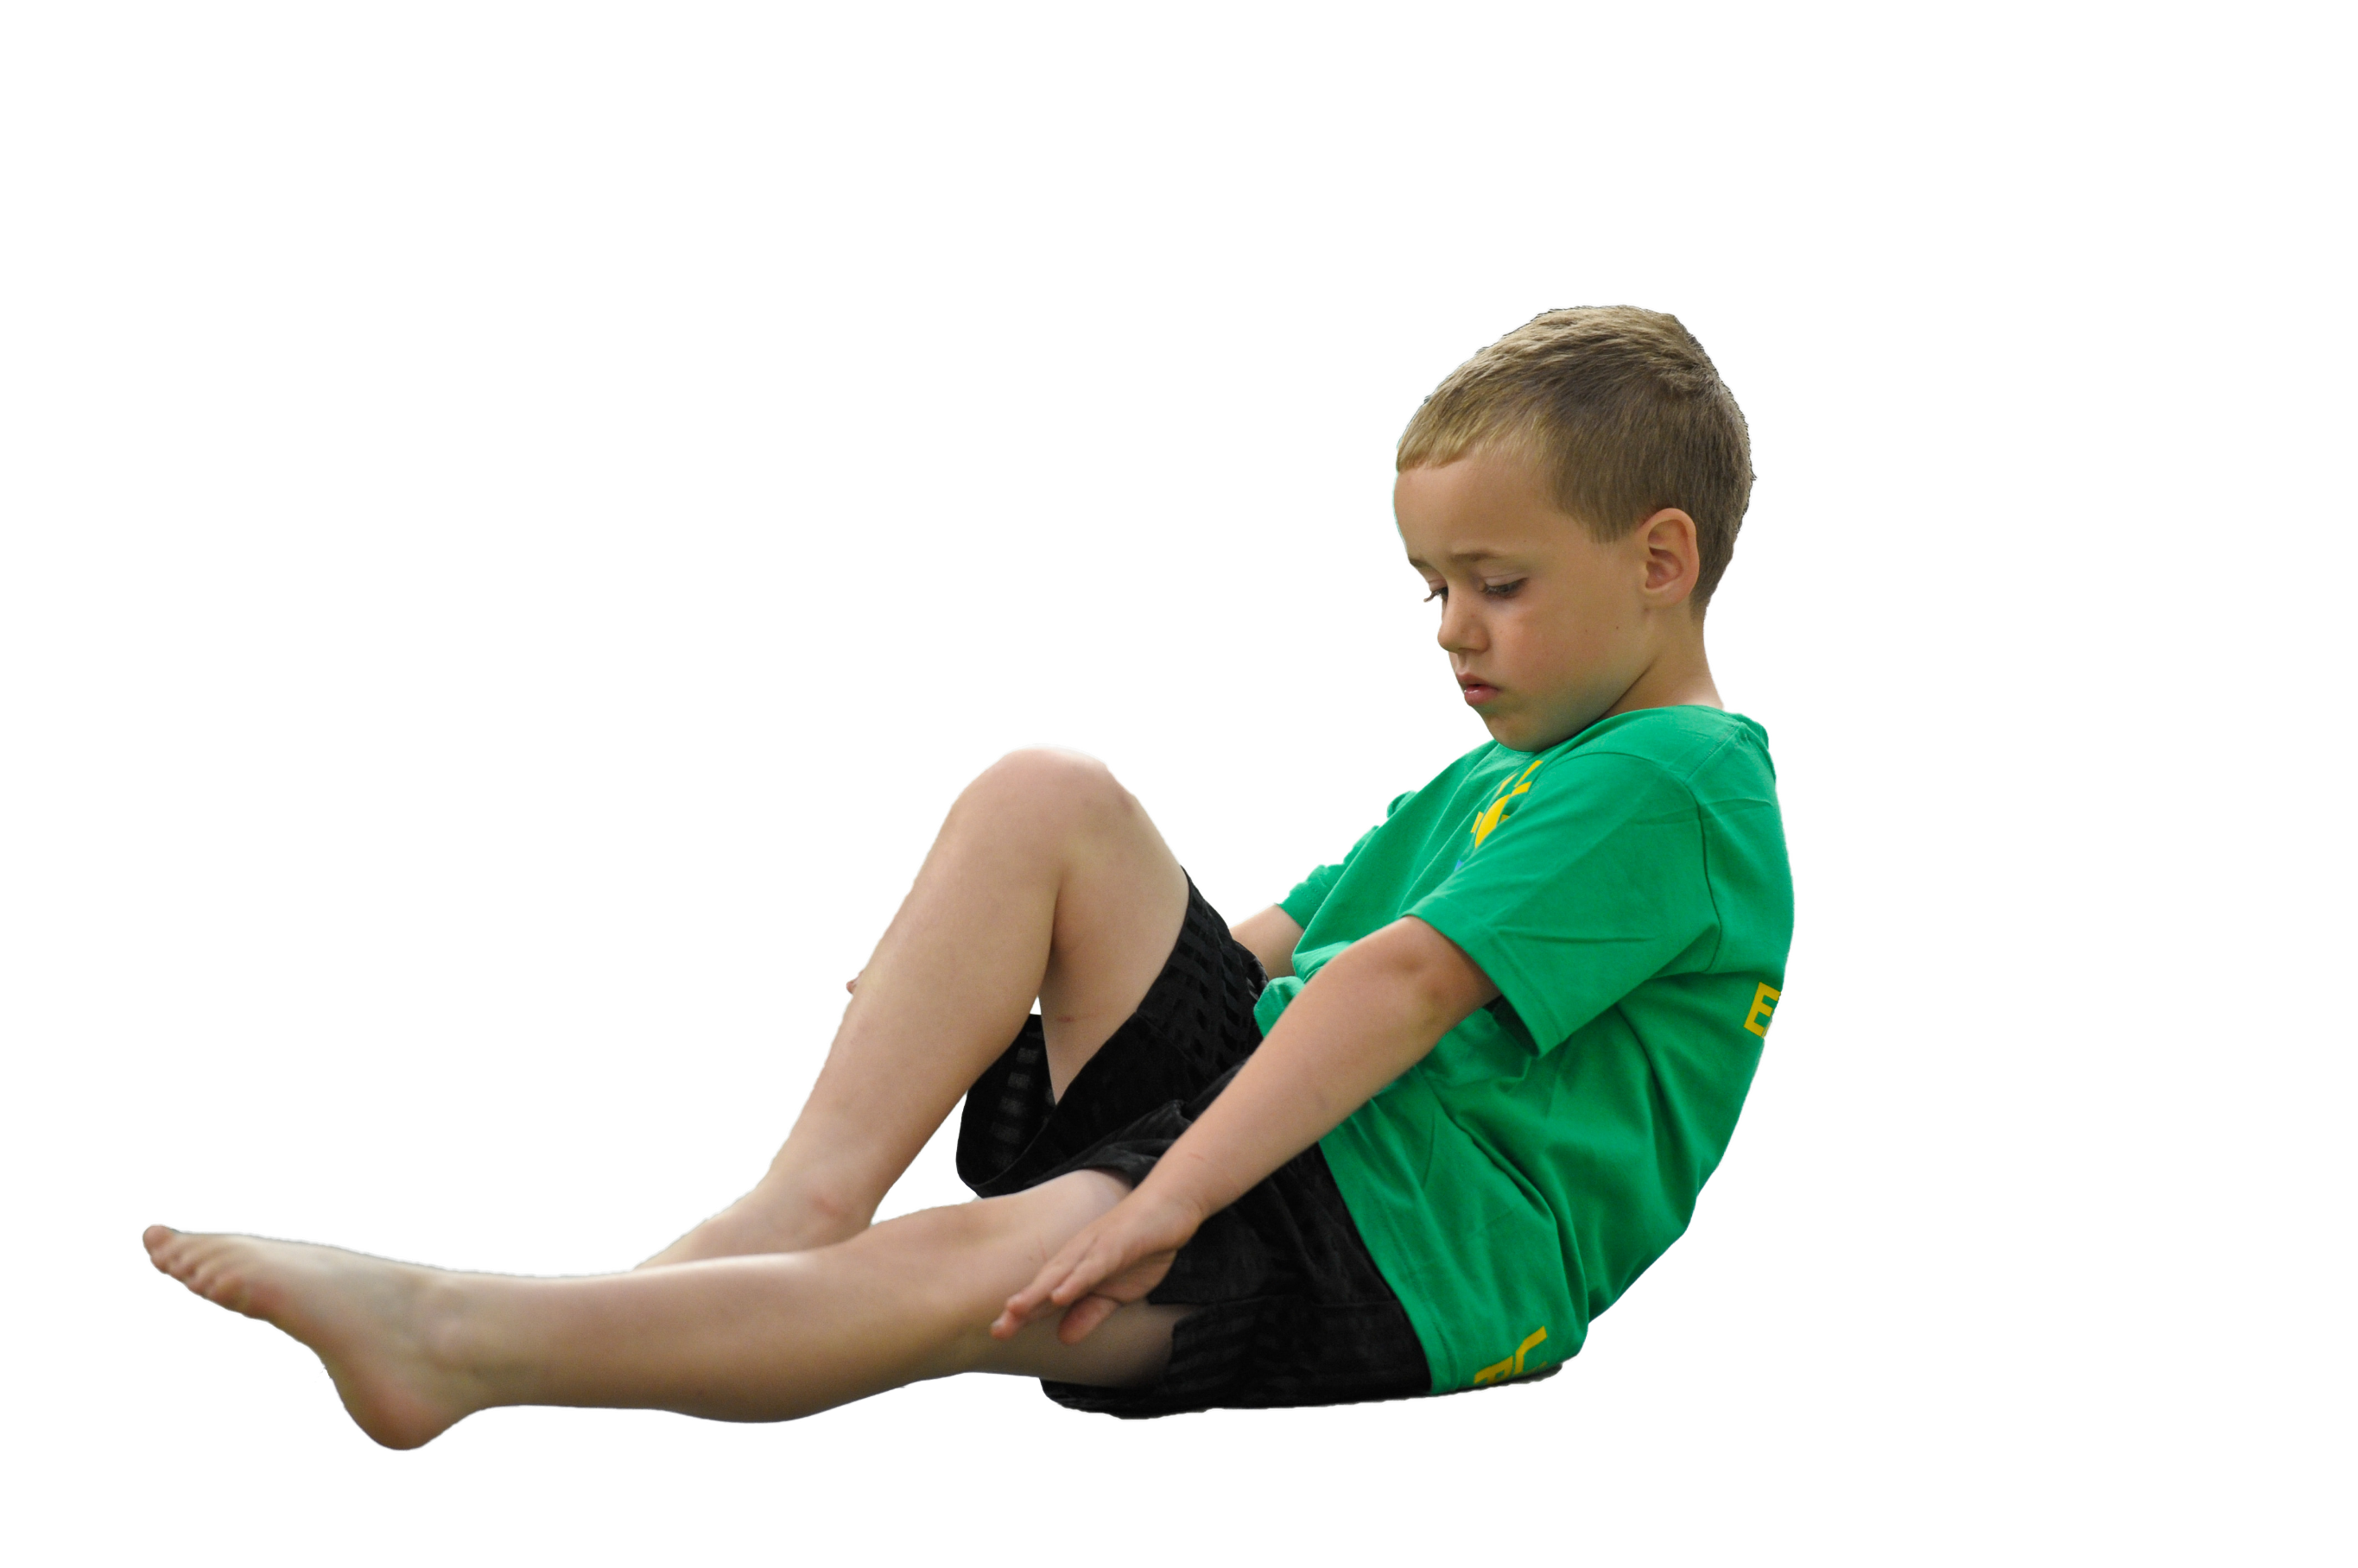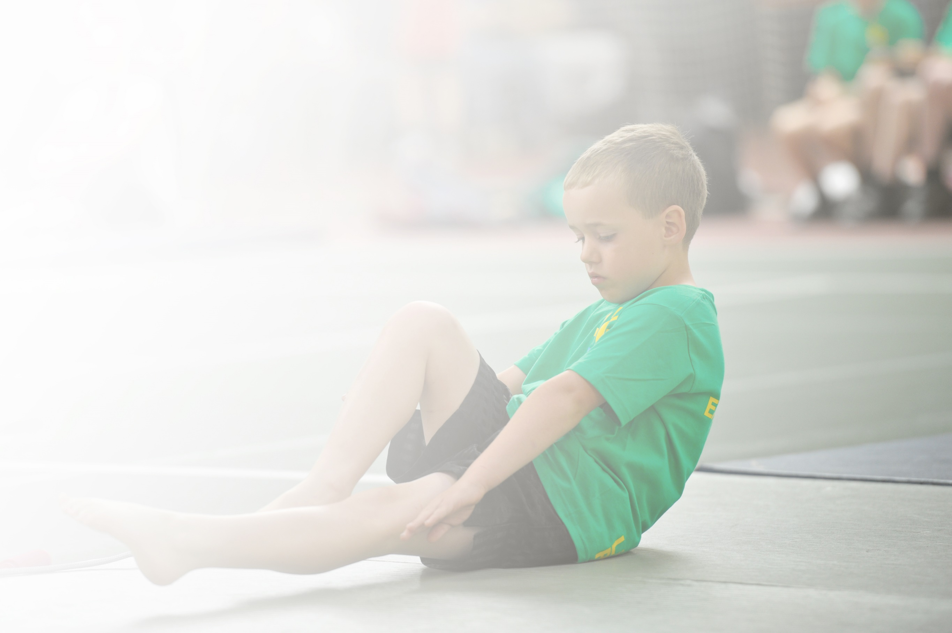Schools must use the funding to make **additional and sustainable** improvements to the quality of Physical Education, Sport and Physical Activity (PESPA) they offer. This means that you should use the Primary PE and Sport Premium to:

* Develop or add to the PESPA activities that your school already offer
* Build capacity and capability within the school to ensure that improvements made now will benefit pupils joining the school in future years

Please visit [gov.uk](https://www.gov.uk/guidance/pe-and-sport-premium-for-primary-schools) for the revised DfE guidance including the 5 key indicators across which schools should demonstrate an improvement. This document will help you to review your provision and to report

your spend. DfE encourages schools to use this template as an effective way of meeting the reporting requirements of the Primary PE and Sport Premium.

We recommend you start by reflecting on the impact of current provision and reviewing the previous

spend. Under the [Ofsted Schools Inspection Framework](https://www.gov.uk/government/publications/school-inspection-handbook-from-september-2015), inspectors will assess how effectively leaders use the Primary PE and Sport Premium and measure its impact on outcomes for pupils, and how effectively [governors](https://www.gov.uk/government/publications/governance-handbook) hold them to account for this.

Schools are required to [publish details](https://www.gov.uk/guidance/what-maintained-schools-must-publish-online#pe-and-sport-premium-for-primary-schools) of how they spend this funding as well as on the impact it has on pupils’ PE and sport participation and attainment by the end of the summer term or by **31 July 2020** at the   
latest.   
  
We recommend regularly updating the table and publishing it  
on your website throughout the year, as evidence of your   
ongoing review into how you are using the money to   
secure maximum, sustainable impact. To see an   
example of how to complete the table please   
click [HERE](http://www.afpe.org.uk/physical-education/wp-content/uploads/afPE-Example-Template-Indicator-2018-Final.pdf).

Support for review and reflection - considering the 5 key indicators from DfE, what development needs are a priority for your setting and your students now and why? Use the space below to reflect on previous spend, identify current need and priorities for the future.

|  |  |
| --- | --- |
| Key achievements to date: | Areas for further improvement and baseline evidence of need: |
| * Achieving the bronze and then the silver sport’s award in the space of two years. * We have successfully delivered the Government recommended 2 hours of good quality PE across the school each week throughout the year for every child. This provision continued for those key worker and vulnerable children who attended school during lock down. It was also provided for the key year groups that attended school after the 1st June. * Our new school initiative of the “Walk to school,” group has been successful and has run every day throughout the year. * Forest school is an established fixture of the school week and every child accesses it throughout the year. | * We are working towards the Gold Sport’s Mark in the coming year. * We want to ensure we maintain the 2 hour provision of PE delivery per week. * We will introduce new extra curricula clubs from 3 per week to 6. These will include alternative sports such as archery and fencing so as to widen their experiences and to engage less active children. |

|  |  |
| --- | --- |
| Meeting national curriculum requirements for swimming and water safety | Please complete all of the below: |
| What percentage of your current Year 6 cohort swim competently, confidently and proficiently over a distance of at least 25 metres?  **N.B.** Even though your children may swim in another year please report on their attainment on leaving  primary school. | Currently unknown. Year 6 were due to attend lessons in the summer term. It is at this point that they would have been assessed and this information collated. |
| What percentage of your current Year 6 cohort use a range of strokes effectively [for example, front crawl, backstroke and breaststroke]? | unknown |
| What percentage of your current Year 6 cohort perform safe self-rescue in different water-based situations? | unknown |
| Schools can choose to use the Primary PE and Sport Premium to provide additional provision for swimming but this must be for activity **over and above** the national curriculum requirements. Have you used it in this way? | Yes, in previous years but this was not possible this academic year. |

**Action Plan and Budget Tracking**

Capture your intended annual spend against the 5 key indicators. Clarify the success criteria and evidence of impact that you intend to measure to evaluate for students today and for the future.

|  |  |  |  |  |
| --- | --- | --- | --- | --- |
| **Academic Year:** 2019/20 | **Total fund allocated:** £17,300 (1,001 unspent to be carried over to the 2020 – 2021 school year) | **Date Updated: July 2020** | |  |
| **Key indicator 1:** The engagement of all pupils in regular physical activity – Chief Medical Officer guidelines recommend that primary school children undertake at least 30 minutes of physical activity a day in school | | | | Percentage of total allocation: |
| **9.2%** |
| School focus with clarity on intended **impact on pupils**: | Actions to achieve: | Funding allocated: | Evidence and impact: | Sustainability and suggested next steps: |
| All children have the opportunity during both morning break and lunch time for physical activity.  All children to be able to swim 25m successfully as well as having basic survival skills in the form of swimming safety  To provide relevant equipment to extend our forest school provision for all pupils. | Children are provided with activities during outside time such as: tennis, basketball nets, football, throw and catch games. When it is wet play, pool, table tennis and dancing with the Wii are available.  Each day there is a 5-Minute-High Intensity training session incorporated into the lunch time play that everyone joins in with.  All pupils have two terms of swimming in Year 3 and those who have not attained the basic standard are offered additional classes in year 4.  Year 6 pupils undertake the swimming safety course in the final term of their time at primary school.  Purchasing additional equipment has enabled all pupils to access forest school activities regularly. It has also provided a medium to promote outdoor experiences for pupils reluctant to be a part of regular sport’s activities. | None – already covered in last year’s allocation  £400  £800 (allocated but unspent)  £1200 | All children are more active throughout the week and of the children interviewed 95% say that they love the challenge.  Children’s enjoyment. Targeting the least active pupils. Providing a wide variety of activities so that a larger majority of pupils find something that they enjoy and are able to sustain.  100% of pupils from year 3 attended the planned sessions, along with repeating year 4 pupils, earlier in the year and attained the basic standard required.  The scheduled swimming safety course was unavailable as the local leisure centre was closed due to Covid-19 restrictions.  All pupils including those attending during lockdown and after the 1st June had regular access to forest school sessions and activities. | To maintain and improve.  The timetabled autumn sessions for the 20-21 school year will be scheduled for the spring term with the hope that these services will be resumed at this time.  Forest school sessions have been scheduled for all bubbles for the autumn term. |
| **Key indicator 2:** The profile of PESSPA being raised across the school as a tool for whole school improvement | | | | Percentage of total allocation: |
| **21.1%** |
| School focus with clarity on intended **impact on pupils**: | Actions to achieve: | Funding allocated: | Evidence and impact: | Sustainability and suggested next steps: |
| Enabling parents to drop children off earlier than the start of school and also to relieve traffic congestion in the local area by providing a free walk to school facility.  Provision of modern, high quality equipment for pupils. | Sports funding used to pay two TAs each morning to work from 8.30, meeting children in the village and walking them to school for the start of the day  Purchase of a range of small games equipment including balls, sticks etc. to be used in invasion games. | £1900  (£1,375 spent)  £2,280 | Up until the beginning of the lockdown period (20th March 2020) this relieved traffic congestion and parent attitudes about parking to a great degree as at least 40 children each morning used the facility. Children were walking half a mile (in a hilly area) to school and therefore starting the day in an active way. The amount of money used from the Sport’s funding budget up until this point was £1,375  Children able to access a variety of sports activities as they have the correct equipment that is of a high quality. | As this has proved such a successful initiative it is one that we would strive to keep even if the funding would disappear. It would be funded through the school’s budget.  The school is looking to introduce a **“walk FROM school,”** initiative in the future.  No more requirement for further spending in the coming year. |

|  |  |  |  |  |
| --- | --- | --- | --- | --- |
| **Key indicator 3:** Increased confidence, knowledge and skills of all staff in teaching PE and sport | | | | Percentage of total allocation: |
| **32.2%** |
| School focus with clarity on intended  **impact on pupils**: | Actions to achieve: | Funding  allocated: | Evidence and impact: | Sustainability and suggested  next steps: |
| By working with Sport’s Stars coaches each week during their PE sessions all staff have received PE CPD by watching and seeing the development in a series of lessons. These then can be used by teachers should the use of Sports Stars be unsustainable in the future.  Coach unlimited program provided for all staff to access high quality planning ideas.  Provision of an IPAD specifically for planning of PE sessions as well as the collation of evidence of activities | All staff delivering PE sessions in collaboration with the sport’s coach. | £5,225  £349 | Teachers are more confident in delivering several aspects of the PE curriculum, should it not be available in coming years, as they have observed them throughout the year and have the plans provided.  Equipment bought to enable staff delivering the sessions to be mobile | Maintain the relationship and attendance of the company to provide free access to afterschool clubs for all pupils in the school. |
| **Key indicator 4:** Broader experience of a range of sports and activities offered to all pupils | | | | Percentage of total allocation: |
| **13%** |
| School focus with clarity on intended  **impact on pupils:** | Actions to achieve: | Funding  allocated: | Evidence and impact: | Sustainability and suggested  next steps: |
| **Additional achievements:**  All teachers believe that additional activities should be available for all pupils and therefore provide a series of afterschool activities free of charge. Many of these are sports based and there is a variety throughout the year.  Active 8 incentive programme, linking pupil’s activity at school to activities at the local leisure centre.  During the partial reopening of the school from the 1st June Superstar Sport were used to provide additional support for group bubbles. This maintained high quality PE provision for all bubble groups whilst adhering to the school’s safety risk assessment.  All children were encouraged to remain active during the period of strict social distancing in school be rethinking playground activities. | Clubs provided by teachers include: football, cross country, football, hockey, summer sports. On Tuesday and Wednesday lunch times there is also a circuits session for whoever wants to take part.  Renew membership in the local scheme.  The company was chosen because of their ability to meet all safety requirements as well as providing high quality activities for the pupils.  Children were encouraged to bring scooters, bicycles and roller skates to school to use during playtime sessions. The school created storage space for them as well as creating access to school bikes and scooters for those who did not have their own equipment. | £250  £2,000  none | Pupils have had their experiences enhanced and have developed a new set of skills as a result.  All children receive 2 hours of quality PE each week delivered by Sports Stars  Children are active before, during and after school. The ability to pay to join clubs is not a hindrance to taking part in an activity.  Pupils choosing to use points earned to continue with physical activities organised locally during holiday periods and after school.  All pupils benefitted from the provision and all PE provision was maintained.  All children were able to be fully active during play sessions whilst staying 2 meters away from their peers. | Sport’s stars to be employed for 3 X afternoon sessions per week to replace 1 full day per week as it was previously.  New Leisure centre owners have agreed to maintain the programme.  This programme was specific to the time of partial opening and the previous school risk assessment. It will not be repeated.  The school plans to timetable these wheelie sessions for larger bubbles once school reopens in the autumn, creating storage facilities for pupil’s personal equipment. |
| **Key indicator 5:** Increased participation in competitive sport | | | | Percentage of total allocation: |
| **18.6%** |
| School focus with clarity on intended  **impact on pupils**: | Actions to achieve: | Funding  allocated: | Evidence and impact: | Sustainability and suggested  next steps: |
| Ensuring that a group of children have the opportunity to attend a county wide competition  NWLSSP – Cross Country events.  Being a part of the North West Leicestershire School Sports Partnership allows Holy Cross, as a small school, to work with the expertise of a bigger local area partnership. | Trials take part during the summer term to choose the best competitors from the school.  All events attended and manned by a member of staff  The school’s PLT attends the NWLSSP meetings and planning events and has used it to plan participation in both the School Sports Mark as well as local sports competitions and events. | Cost of transport to residential and Saffron Lane  £1000 (allocated but unspent)  £3150 | The school was unable to take part in the planned sport’s competitions in the summer term because of the Covid-19 restrictions. £70 was spent on transport for events attended before lockdown took effect  This membership was maintained throughout the 19-20 school year and the allocated funding was spent. | Maintain the provision and level of these activities with the hope that they will be available in the summer term 2021 |