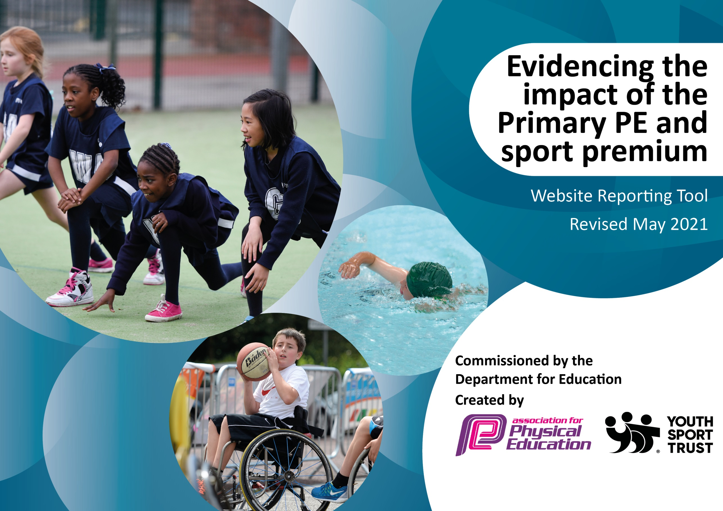

It is important that your grant is used effectively and based on school need. The Education Inspection Framework (Ofsted 2019 p64) makes clear there will be a focus on **‘whether leaders and those responsible for governors all understand their respective roles and perform these in a way that enhances the effectiveness of the school’**.

Under the Quality of Education criteria (p41) inspectors consider the extent to which schools can articulate their curriculum (INTENT), construct their curriculum (IMPLEMENTATION) and demonstrate the outcomes which result (IMPACT).

To assist schools with common transferable language this template has been developed to utilise the same three headings which should make your plans easily transferable between working documents.

Schools must use the funding to make **additional and sustainable** improvements to the quality of Physical Education, School Sport and Physical Activity (PESSPA) they offer. This means that you should use the Primary PE and sport premium to:

* Develop or add to the PESSPA activities that your school already offer
* Build capacity and capability within the school to ensure that improvements made now will benefit pupils joining the school in future years
* The Primary PE and sport premium should not be used to fund capital spend projects; the school’s budget should fund these.

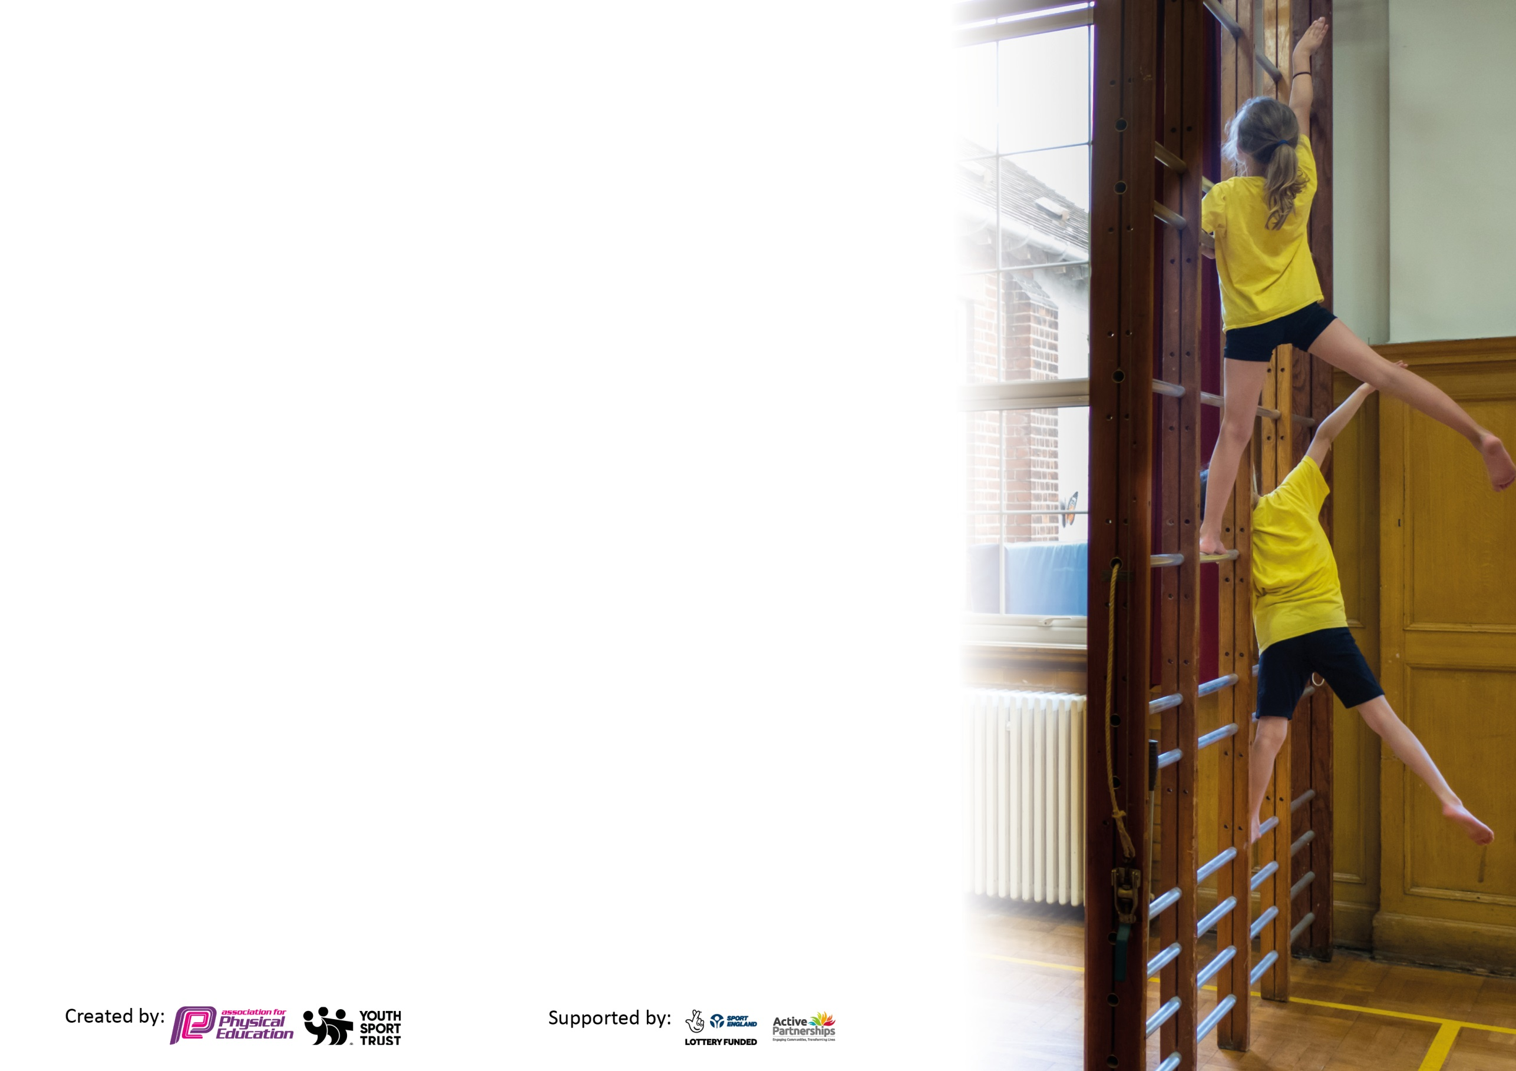

Please visit gov.uk for the revised DfE guidance including the 5 key indicators across which schools should demonstrate an improvement. This document will help you to review your provision and to report your spend. DfE encourages schools to use this template as an effective way of meeting the reporting requirements of the Primary PE and sport premium.

We recommend you start by reflecting on the impact of current provision and reviewing the previous spend.

Schools are required to publish details of how they spend this funding, including any under-spend from 2019/2020, as well as on the impact it has on pupils’ PE and sport participation and attainment by the end of the summer term or by **31st July 2021** at the latest.

We recommend regularly updating the table and publishing it on your website throughout the year. This evidences your ongoing self-evaluation of how you are using the funding to secure maximum, sustainable impact. Final copy must be posted on your website by the end of the academic year and no later than the 31st July 2021. To see an example of how to complete the table please click HERE.



Please note: Although there has been considerable disruption in 2020 it is important that you publish details on your website of how you spend the funding - this is a legal requirement.

Support for review and reflection - considering the 5 key indicators from DfE, what development needs are a priority for your setting and your pupils now and why? Use the space below to reflect on previous spend and key achievements and areas for development.

N.B. In this section you should refer to any adjustments you might have made due to Covid-19 and how these will influence further improvement.

|  |  |
| --- | --- |
| Key achievements to date until July 2020: | Areas for further improvement and baseline evidence of need: |
| * Achieving the bronze and then the silver sport’s award in the space of two years. * We have successfully delivered the Government recommended 2 hours of good quality PE across the school each week throughout the year for every child who was in school. It was also provided for the key year groups that attended school after the 1st June. * All children who were home schooled were given access to a full programme of PE provided by the local School Sport’s Partnership. * Our school initiative of the “Walk to school,” group has been successful and the school took part in the local government WOW initiative. * Forest school is an established fixture of the school week and it was provided for all children attending school during the lockdown periods. * Year 6 received First Aid training along with CPR training. * We were able to provide Bikeability level 1 to Year 4 and Bikeability Level 2 to Year 6 this year. | * We would like to provide first aid training with all of KS2 so everyone has access to the key skills. This would include CPR training. The school has purchased a Defibrilator and we would like all children to know of its importance for the school and the local community. * We would like to provide all of KS1 with balance bike bikeability. Many of our older children cannot ride a bicycle and we would like to address this problem in the Early Years so there is more success in achieving Level 2 Bikeability in KS2 |

Did you carry forward an underspend from 2019-20 academic year into the current academic year? YES/~~NO *~~ Delete as applicable

**Total amount carried forward from 2019/2020 £1001**

**+ Total amount for this academic year 2020/2021 £17,300**

**= Total to be spent by 31st July 2021 £18,301**

|  |  |
| --- | --- |
| Meeting national curriculum requirements for swimming and water safety.  N.B Complete this section to your best ability. For example you might have practised safe self-rescue techniques on dry land which you can transfer to the pool when school swimming restarts.  **Due to exceptional circumstances priority should be given to ensuring that pupils can perform safe self rescue even**  **if they do not fully meet the first two requirements of the NC programme of study.** |  |
| What percentage of your current Year 6 cohort swim competently, confidently and proficiently over a distance of at least 25 metres?  **N.B.** Even though your pupils may swim in another year please report on their attainment on leaving primary school at the end of the summer term 2021.  Please see note above. | Unknown as the children have not been assessed this year. |
| What percentage of your current Year 6 cohort use a range of strokes effectively [for example, front crawl, backstroke and breaststroke]?  Please see note above. | Unknown for the reasons above. |
| **What percentage of your current Year 6 cohort perform safe self-rescue in different water-based situations?** | Unknown |
| Schools can choose to use the Primary PE and sport premium to provide additional provision for swimming but this must be for activity **over and above** the national curriculum requirements. Have you used it in this way? | No- there has not been the opportunity this year. |

**Action Plan and Budget Tracking**

Capture your intended annual spend against the 5 key indicators. Clarify the success criteria and evidence of impact that you intend to measure to evaluate for pupils today and for the future.

|  |  |  |  |  |
| --- | --- | --- | --- | --- |
| **Academic Year:** 2020/21 | **Total fund allocated:** £17,700 | **Date Updated:** | |  |
| **Key indicator 1:** The engagement of all pupils in regular physical activity – Chief Medical Officers guidelines recommend that primary school pupils undertake at least 30 minutes of physical activity a day in school | | | | Percentage of total allocation: |
| 20% |
| **Intent** | **Implementation** | | **Impact** |  |
| Your school focus should be clear what you want the pupils to know and be able to do and about  what they need to learn and to  consolidate through practice: | Make sure your actions to achieve are linked to your intentions: | Funding allocated: | Evidence of impact: what do pupils now know and what can they now do? What has changed?: | Sustainability and suggested next steps: |
| All children have the opportunity during both morning break and lunch time for physical activity.  All children enrolled in the local government Active8 programme. | Children are provided with activities during outside time such as: tennis, basketball nets, football, throw and catch games. Children are also given the opportunity to bring roller skates and scooters into school and have the opportunity to use these in our “Walk to School,” facility. When it is wet play, pool, table tennis and dancing with the Wii are available.  The playground has an outdoor Table Tennis Table, Tennis nets and Basketball nets.  In doors there is a pool table and darts, a Wii and a full range of indoor equipment including a Table Tennis Table.  Activities participated in, in school are registered with the programme enabling children to gather activity points that can then be spent in the local leisure centre, contributing to the cost of activities. | £1000  £2500 | All break time activities are active ones. Many children have learnt new skills such as how to:  Rollerskate,  Skateboard,  Play Basketball.  Play table Tennis  Play Tennis  100% of our children have accessed the active 8 scheme over the past year. There have been 173 activities completed. | To continue updating sport’s equipment so that the children have a wide choice of activities and therefore something that will interest them and encourage them to learn a new skill. |
| **Key indicator 2:** The profile of PESSPA being raised across the school as a tool for whole school improvement | | | | Percentage of total allocation: |
| 48% |
| **Intent** | **Implementation** | | **Impact** |  |
| Your school focus should be clear what you want the pupils to know and be able to do and about  what they need to learn and to  consolidate through practice: | Make sure your actions to achieve are linked to your intentions: | Funding allocated: | Evidence of impact: what do pupils now know and what can they now do? What has changed?: | Sustainability and suggested next steps: |
| Enabling parents to drop children off earlier than the start of school and also to relieve traffic congestion in the local area by providing a free walk to school facility.  Provision of modern, high quality equipment for pupils.  All children to be offered the opportunity of an after school activity club, provided by high quality sport’s coaches, free of charge. | Sports funding used to pay two TAs each morning to work from 8.30am, meeting children in the village and walking them to school for the start of the day.  Funding used to provide 3 afternoons of quality PE activities as well as extended school activities for all pupils. | £8500 | Children active whilst in school for at least two hours per week.  All Afterschool clubs have had an active element.  Children’s fitness has improved since returning from Lockdown. | Continue this provision whilst funding still exists and ensure those that did not access it this year are offered places first. |

|  |  |  |  |  |
| --- | --- | --- | --- | --- |
| **Key indicator 3:** Increased confidence, knowledge and skills of all staff in teaching PE and sport | | | | Percentage of total allocation: |
| 6% |
| **Intent** | **Implementation** | | **Impact** |  |
| Your school focus should be clear | Make sure your actions to | Funding | Evidence of impact: what do | Sustainability and suggested |
| what you want the pupils to know | achieve are linked to your | allocated: | pupils now know and what | next steps: |
| and be able to do and about | intentions: |  | can they now do? What has |  |
| what they need to learn and to |  |  | changed?: |  |
| consolidate through practice: |  |  |  |  |
| Purchase of the PE scheme containing long and medium term planning. | Previous Sport’s spending enabled all staff to have access to high quality CPD as provided by Sport’s coaches when they worked in collaboration delivering PE lessons.  The scheme that has been purchased has detailed planning that allows staff to ensure that there is progression of skills within and beyond their lessons. The progression in the scheme also ensures that children are acquiring new skills that are building on competences mastered in previous year groups. | £1000 | Staff are confident at delivering high quality sport’s sessions as well as having the equipment available to carry out the lesson.  They are confident that there is a progression of skills and that they are contributing to complete curriculum coverage. | Continue to deliver high quality PE sessions with regular refresher CPD sessions |
| **Key indicator 4:** Broader experience of a range of sports and activities offered to all pupils | | | | Percentage of total allocation: |
| 12% |
| **Intent** | **Implementation** | | **Impact** |  |
| Your school focus should be clear | Make sure your actions to | Funding | Evidence of impact: what do | Sustainability and suggested |
| what you want the pupils to know | achieve are linked to your | allocated: | pupils now know and what | next steps: |
| and be able to do and about | intentions: |  | can they now do? What has |  |
| what they need to learn and to |  |  | changed?: |  |
| consolidate through practice: |  |  |  |  |
| Additional achievements:  Forest school for all pupils to experience a different range of outdoor activities.  Year 4 and 6 pupils offered Bikeability training.  Year 6 pupil offered First aid training including CPR training. | All children in school have attended several sessions of forest school throughout the year learning a range of new skills, such a clearing, planting, fire safety, outdoor cooking, outdoor craft etc.  All children in both Year 4 and 6 signed up for Bikeability training.  All year 6 pupils spent a day having training during the school day. | £1000  £1150 | Children have attained the skills needed to work and play in the forest area safely. They have learnt tree and plant identification. They know the rules of Fire Safety outdoors.  Children are competent at riding bikes, for those at level 2 they know road safety and are competent enough to ride on the road for the purpose of getting to school or for social purposes. | We would like to extend Bikeability training to KS1 pupils through the use of balance bikes so that they are competent at an earlier age. |

|  |  |  |  |  |
| --- | --- | --- | --- | --- |
| **Key indicator 5:** Increased participation in competitive sport | | | | Percentage of total allocation: |
| 18% |
| **Intent** | **Implementation** | | **Impact** |  |
| Your school focus should be clear | Make sure your actions to | Funding | Evidence of impact: what do | Sustainability and suggested |
| what you want the pupils to know | achieve are linked to your | allocated: | pupils now know and what | next steps: |
| and be able to do and about | intentions: |  | can they now do? What has |  |
| what they need to learn and to |  |  | changed?: |  |
| consolidate through practice: |  |  |  |  |
| This has not been possible this year however we did subscribe to the North West Leicestershire School Sports Partnership |  |  |  |  |

|  |  |
| --- | --- |
| Signed off by | |
| Head Teacher: | Mrs Siobhan Minford |
| Date: | 09.07.21 |
| Subject Leader: | Mr Andy Morley |
| Date: | 09.07.21 |
| Governor: | Mr Gerry Hirst |
| Date: | 09.07.21 |