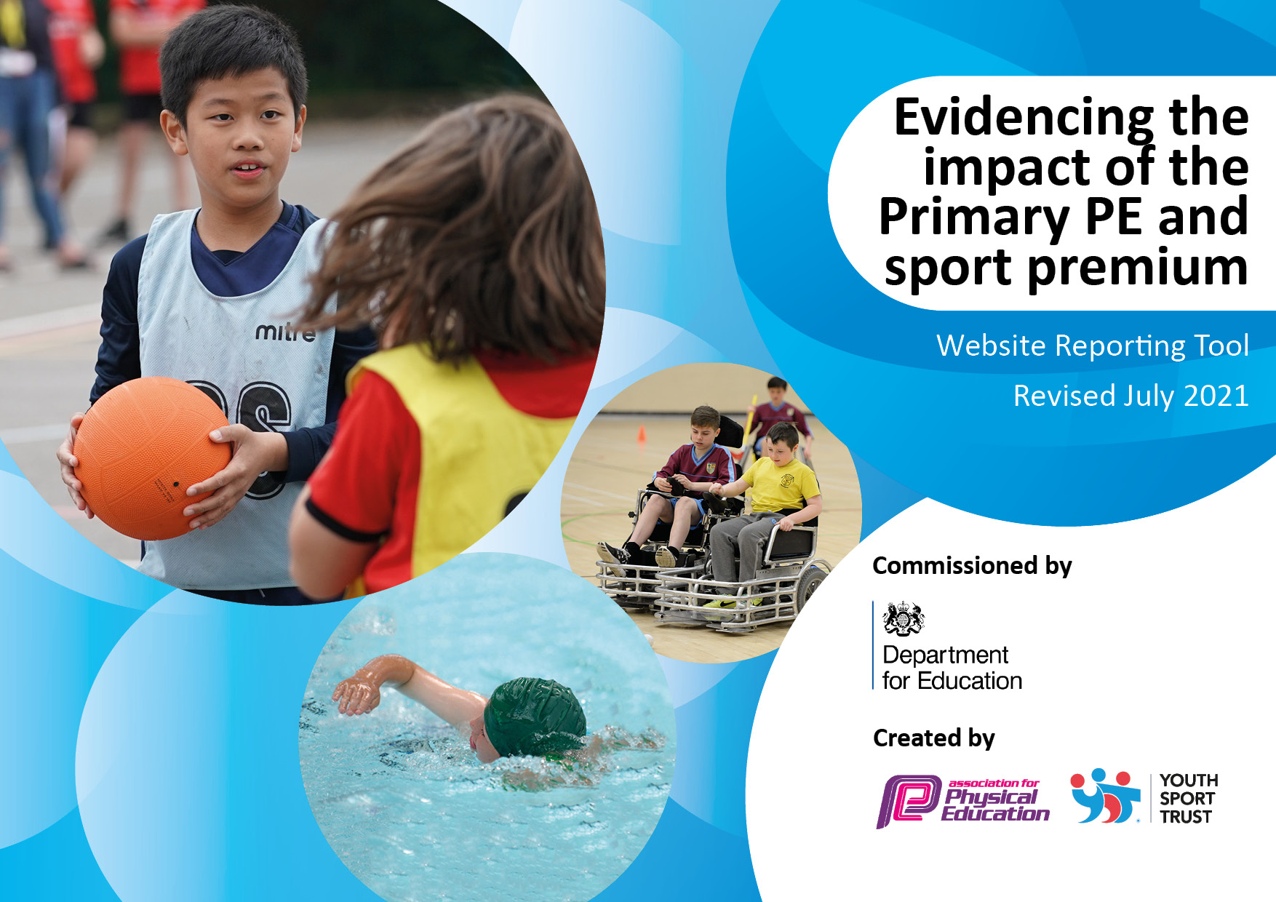

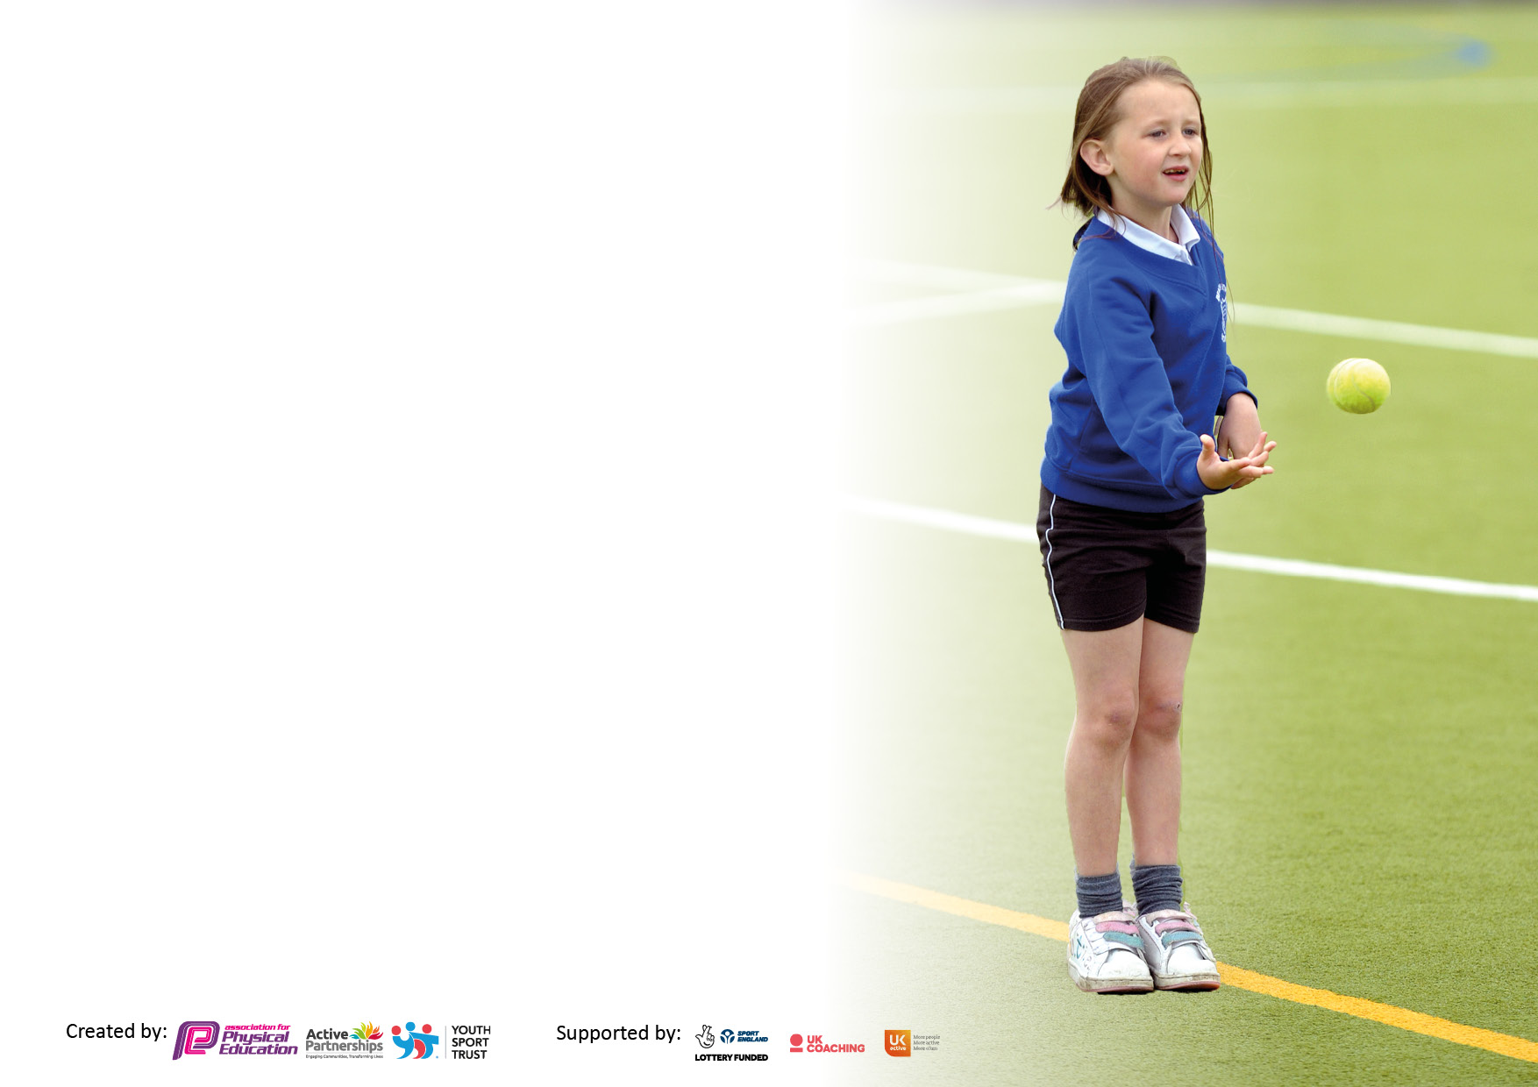

It is important that your grant is used effectively and based on school need. The Education Inspection Framework makes clear there will be a focus on **‘whether leaders and those responsible for governors all understand their respective roles and perform these in a way that enhances the effectiveness of the school’**.

Under the Quality of Education Ofsted inspectors consider:

**Intent** - Curriculum design, coverage and appropriateness

**Implementation** - Curriculum delivery, Teaching (pedagogy) and Assessment

**Impact** - Attainment and progress

To assist schools with common transferable language this template has been developed to utilise the same three headings which should make your plans easily transferable between working documents.

Schools must use the funding to make **additional and sustainable** improvements to the quality of Physical Education, School Sport and Physical Activity (PESSPA) they offer. This means that you should use the Primary PE and sport premium to:

* Develop or add to the PESSPA activities that your school already offer
* Build capacity and capability within the school to ensure that improvements made now will benefit pupils joining the school in future years
* The Primary PE and sport premium should not be used to fund capital spend projects; the school’s budget should fund these.

Pleasevisitgov.ukfortherevisedDfEguidanceincludingthe5keyindicatorsacrosswhichschoolsshoulddemonstrate animprovement.Thisdocumentwillhelpyoutoreviewyourprovisionandtoreportyourspend.DfEencouragesschools to use this template as an effective way of meeting the reporting requirements of the Primary PE and sport premium.

We recommend you start by reflecting on the impact of current provision and reviewing the previous spend.

Schools are required to publish details of how they spend this funding, including any under-spend from 2019/2020, as well as on the impact it has on pupils’ PE and sport participation and attainment. **All funding must be spent by 31st July 2022.**

We recommend regularly updating the table and publishing it on your website throughout the year. This evidences your ongoing self-evaluation of how you are using the funding to secure maximum, sustainable impact. Final copy must be posted on your website by the end of the academic year and no later than the 31st July 2021. To see an example of how to complete the table please click HERE.

Created by: Supported by:

**Details with regard to funding**

Please complete the table below.

|  |  |
| --- | --- |
| Total amount carried over from 2020/21 | £ 0 |
| Total amount allocated for 2021/22 | £ 17,390 |
| How much (if any) do you intend to carry over from this total fund into 2022/23? | £ 440 |
| Total amount allocated for 2022/23 | £ 17,830 |
| Total amount of funding for 2022/23. To be spent and reported on by 31st July 2023. | £ 17,830 |

**Swimming Data**

Please report on your Swimming Data below.

|  |  |
| --- | --- |
| Meeting national curriculum requirements for swimming and water safety.  N.B. Complete this section to your best ability. For example you might have practised safe self-rescue techniques on dry land which you can then transfer to the pool when school swimming restarts.  **Due to exceptional circumstances priority should be given to ensuring that pupils can perform safe self rescue even if they do not fully meet the first two requirements of the NC programme of study** |  |
| What percentage of your current Year 6 cohort swim competently, confidently and proficiently over a distance of at least 25 metres?  **N.B.** Even though your pupils may swim in another year please report on their attainment on leaving primary school at the end of the summer term 2021.  Please see note above | 80% |
| What percentage of your current Year 6 cohort use a range of strokes effectively [for example, front crawl, backstroke and breaststroke]?  Please see note above | 80% |
| **What percentage of your current Year 6 cohort perform safe self-rescue in different water-based situations?** | 50% |
| Schools can choose to use the Primary PE and sport premium to provide additional provision for swimming but this must be for activity **over and above** the national curriculum requirements. Have you used it in this way? | No |

**Action Plan and Budget Tracking**

Capture your intended annual spend against the 5 key indicators. Clarify the success criteria and evidence of impact that you intend to measure to evaluate for pupils today and for the future.

|  |  |  |  |  |
| --- | --- | --- | --- | --- |
| **Academic Year:** 2021/22 | **Total fund allocated:** | **Date Updated:** | |  |
| **Key indicator 1:** The engagement of all pupils in regular physical activity – Chief Medical Officers guidelines recommend that primary school pupils undertake at least 30 minutes of physical activity a day in school | | | | Percentage of total allocation: |
| 7.9% |
| **Intent** | **Implementation** | | **Impact** |  |
| Your school focus should be clear what you want the pupils to know and be able to do and about  what they need to learn and to  consolidate through practice: | Make sure your actions to achieve are linked to your intentions: | Funding allocated: | Evidence of impact: what do pupils now know and what can they now do? What has changed?: | Sustainability and suggested next steps: |
| All children at Holy Cross will have access to high quality physical education provision throughout the school day. This will be interleaved through walking to school schemes, before and after school activity clubs as well as through the formal national curriculum | Children are provided with activities during outside time such as: tennis, basketball nets, football, throw and catch games. Children are also given the opportunity to bring roller skates and scooters into school and have the opportunity to use these in our “Walk to School,” facility. When it is wet play, pool, table tennis and dancing with the Wii are available.  The playground has an outdoor Table Tennis Table, Tennis nets and Basketball nets.  In doors there is a pool table and darts, a Wii and a full range of indoor equipment including a Table Tennis Table.  Activities participated in, in school are registered with the programme enabling children to gather activity points that can then be spent in the local leisure centre, contributing to the cost of activities. | £1405 | The walk to school scheme has on average between 30 and 40 children walking to school each morning. Parents state that they rely on the service and children said they liked walking to school, joining the scheme through choice rather than necessity.  The before and after school care club was attended on average by around 35 children each day.  The combination of the above provision means that over 50% of our children had an active start to their day before formal learning began.  Children’s fitness levels have improved and fitness has been regained after the lockdown periods of inactivity.  Children are active at break and lunch times as the use of roller skate, skateboards, scooters and sport’s equipment has meant that they have a varied selection of activities to choose from. | Maintain the equipment we have and look for an alternative to the aging trim trail with the help from the school’s Friends Association. |
| **Key indicator 2:** The profile of PESSPA being raised across the school as a tool for whole school improvement | | | | Percentage of total allocation: |
| 59.8% |
| **Intent** | **Implementation** | | **Impact** |  |
| Your school focus should be clear what you want the pupils to know and be able to do and about  what they need to learn and to  consolidate through practice: | Make sure your actions to achieve are linked to your intentions: | Funding allocated: | Evidence of impact: what do pupils now know and what can they now do? What has changed?: | Sustainability and suggested next steps: |
| Enabling parents to drop children off earlier than the start of the school day and also to relieve traffic congestion in the local area by providing a free walk to school facility. Parents feel more secure dropping children off during quieter traffic times.  Provision of modern, high-quality equipment for pupils. Providing additional storage so that children can supplement their playtimes by bringing and leaving their own equipment in the knowledge that it is safe.  All children to be offered the opportunity of an after-school activity club, provided by high quality sport’s coaches, free of charge. | Sports funding used to pay two TAs each morning to work from 8.30am, meeting children in the village and walking them to school for the start of the day.  Funding used to provide 3 afternoons of quality PE activities as well as extended school activities for all pupils.  Provide outside storage containers for outdoor equipment and children’s skates etc. | £10,660 | Children active whilst in school for at least two hours per week.  All Afterschool clubs have had an active element.  Children’s fitness has improved since returning from Lockdown | Another year of funding will ensure that the “walk to school,” scheme remains in its current format.  Maintain current equipment and replace where necessary.  Maintain the supply of sports coaches for school clubs so all children can access them. |

|  |  |  |  |  |
| --- | --- | --- | --- | --- |
| **Key indicator 3:** Increased confidence, knowledge and skills of all staff in teaching PE and sport | | | | Percentage of total allocation: |
| 0% |
| **Intent** | **Implementation** | | **Impact** |  |
| Your school focus should be clear | Make sure your actions to | Funding | Evidence of impact: what do | Sustainability and suggested |
| what you want the pupils to know | achieve are linked to your | allocated: | pupils now know and what | next steps: |
| and be able to do and about | intentions: |  | can they now do? What has |  |
| what they need to learn and to |  |  | changed?: |  |
| consolidate through practice: |  |  |  |  |
| Modification, adaption and embedding of the PE scheme containing long and medium term planning. | Lessons adapted to meet the needs of individuals and groups.  Whole scheme mapped to ensure progression and a good level of challenge for pupils.  A clear overview of the concepts children are to be taught as well as the vocabulary we want children to be fluent in when talking about their physical health and well-being. | £0 | Children can talk confidently about their fitness and what they need to do to keep their bodies healthy. Teachers know what the end points are for each year group, what previous activities they have covered and what skills and knowledge they are building towards. | Continue to further develop and enhance the scheme so that it supports the needs of all pupils and the curriculum. |
| **Key indicator 4:** Broader experience of a range of sports and activities offered to all pupils | | | | Percentage of total allocation: |
| 6.6% |
| **Intent** | **Implementation** | | **Impact** |  |
| Your school focus should be clear | Make sure your actions to | Funding | Evidence of impact: what do | Sustainability and suggested |
| what you want the pupils to know | achieve are linked to your | allocated: | pupils now know and what | next steps: |
| and be able to do and about | intentions: |  | can they now do? What has |  |
| what they need to learn and to |  |  | changed?: |  |
| consolidate through practice: |  |  |  |  |
| Additional achievements:  Forest school for all pupils to experience a different range of outdoor activities.  Year 4 and 6 pupils offered Bikeability training.  Year 6 pupil offered First aid training including CPR training. | All children in school have attended several sessions of forest school throughout the year learning a range of new skills, such a clearing, planting, fire safety, outdoor cooking, outdoor craft etc.  All children in both Year 4 and 6 signed up for Bikeability training.  All year 6 pupils spent a day having training during the school day. | £1175 | Children have attained the skills needed to work and play in the forest area safely. They have learnt tree and plant identification. They know the rules of Fire Safety outdoors.  Children are competent at riding bikes, for those at level 2 they know road safety and are competent enough to ride on the road for the purpose of getting to school or for social purposes. | We would like to extend Bikeability training to KS1 pupils through the use of balance bikes so that they are competent at an earlier age. |

|  |  |  |  |  |
| --- | --- | --- | --- | --- |
| **Key indicator 5:** Increased participation in competitive sport | | | | Percentage of total allocation: |
| 25.7% |
| **Intent** | **Implementation** | | **Impact** |  |
| Your school focus should be clear | Make sure your actions to | Funding | Evidence of impact: what do | Sustainability and suggested |
| what you want the pupils to know | achieve are linked to your | allocated: | pupils now know and what | next steps: |
| and be able to do and about | intentions: |  | can they now do? What has |  |
| what they need to learn and to |  |  | changed?: |  |
| consolidate through practice: |  |  |  |  |
| To be part of a local school sports partnership that will enable pupil access to competitive events.  Children to be part of the local leisure centre Active 8 scheme to promote the taking part of sport outside of school hours for families who may not be able to afford them. | Pay into Option 1 of the North West Leicestershire School Sport’s Partnership. This will allow access to all events and competitions for the year.  Pay into the membership of the Active 8 scheme. | £4590 | Children were able to attend all events where the funding also stretched to the hire of transport to get to and from the events. | Maintain membership in whatever form it may take. |

|  |  |
| --- | --- |
| Signed off by | |
| Head Teacher: | Mrs Siobhan Minford |
| Date: | 08.07.22 |
| Subject Leader: | Mr Andrew Morley |
| Date: | 08.07.22 |
| Governor: | Mrs Sarah Tebbett |
| Date: | 08.07.22 |